Architectural Description of the Menu Component
BRAINTRIBE IT Techinologies

MenuModule
Introduction
The MenuModule is a component which wrappers widgets like a common menu that supply, for example, some items for users click on.
Using It is possible attach others components caring for presentation and organization and listeners events (in some cases) of the items inside him.
MenuModule(so far but from now just Menu) is not an extend from the com.gwtext.client.widgets.menu.Menu class rather it extends a gwtext panel and it encapsules two others panels for mounts the possible layouts.
The Component Description
The MenuModule is rather a visual component using GWTEXT Components for places widgets like as follows; it’s showed a MenuModule (embraced by red line) with options ‘buttons’ which a user could click on.

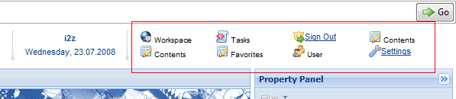
Picture 1 - Example of the MenuModule.

As it can be saw there are two rows of ‘buttons’ although it can be more it’s better use so, just adding more ‘buttons’ to ‘columns’ like is illustrated in picture 1.
The component configuration
To create a new Menu first at MenuModule/trunk directory running ant install it will create the .jars files in
{home}\ .m2\repository\com\braintribe\gwt\MenuModule\..\*.jar then adds to classpath your application.
There are two types of ‘buttons’ that can be used: Labels (with listeners yet) and Hyperlinks which the name give some clue.
Now to create a new instance of the Menu component just code that:
CustomMenu menu = new CustomMenu();
And to inserts the ‘buttons’ just choose top or bottom panels so menu.getTopPanel().addButton(‘iconPath’, ‘Login’, clicklistener);
menu.getTopPanel().addLabel(‘inconPath’,label);
After all buttons had been inserted invoke:
menu.applyPanel(CustomMenu.TOP_PANEL);
if you use:
menu.getBottomPanel().addButton(‘iconPath’, ‘Login’, clicklistener);
then after all you call:
menu.applyPanel(CustomMenu.BOTTOM_PANEL);
This last method apply actually the buttons to menu so after adding the buttons call its respective method.
After this you can get the instance and use it.
Project Integration
To integrate the Menu in GWT project you must configure the build of the your project to adds the MenuModule at moment of deploy. That is made informing the dependency to pom.xml
And adding the MenuModule reference to GWT module which will use the Menu.
For example:
<ant dir="MenuModule/trunk" target="${target}"/>

Practical Example
The follow picture is the code for implementing the menu like which is showed in picture above. Here it is used provider concept but just look at inside of the create method to understand.
